**SYNOPSIS**

# Report on

**Online Used Books Selling**

**By**

Name : Shivanshu Panwar

Roll. Number : 2200290140148

**Session:2023-2024 (III Semester)**

Under the supervision of

# Dr. Amit Kumar

# Assistant Professor

## KIET Group of Institutions, Delhi-NCR, Ghaziabad



**DEPARTMENT OF COMPUTER APPLICATIONS**

**KIET GROUP OF INSTITUTIONS, DELHI-NCR, GHAZIABAD-201206**

## ABSTRACT

The Online Used Books Selling Project is an innovative e-commerce platform designed to facilitate the buying and selling of pre-owned books. This project aims to provide a userfriendly and efficient marketplace for book enthusiasts to connect, trade, and explore a vast collection of used books. The platform offers a seamless and secure online experience for both buyers and sellers, making it easier for individuals to access affordable books.

Key components of this project include the development of a user-friendly e-commerce website, the establishment of a diverse inventory of high-quality used books, and the cultivation of a loyal customer base. The project focuses on ensuring customer satisfaction through exceptional service, reliable product listings, and a commitment to quality.

Furthermore, this venture is underpinned by a strong sense of social responsibility. It actively supports literacy initiatives, donates books to charitable causes, and engages in partnerships with educational institutions. By promoting sustainability and accessibility, the project seeks to make a meaningful impact on society and the environment.

The Online Used Books Selling Project offers an ideal solution for anyone looking to monetize their old books or find quality used books at competitive prices. By creating a dynamic online marketplace, this project fosters a thriving community of book lovers while supporting sustainability and affordability in the world of literature

Keywords : - e-commerce, user-friendly , e-commerce , books etc.

# TABLE OF CONTENTS

Page Number

1. Introduction --
2. Literature Review --
3. Project / Research Objective --
4. Research Methodology --
5. Project / Research Outcome --
6. Proposed Time Duration --
7. References --

## Introduction

### 1.1 Project Introduction

E-commerce is fast gaining ground as an accepted and used business paradigm. More and more business houses are implementing web sites providing functionality for performing commercial transactions over the web. It is reasonable to say that the process of shopping on the web is becoming common place. Online second hand book can be introduced as an online platform where the customer can buy books. Along with the advancement of technology, people are more likely to prefer technological accessories and those who prefer them are not necessarily aware about its features. The objective of this project is to develop a general purpose e-commerce website where used books can be bought from the home through the internet.

#### 1.2 Problem Statement

In today’s world money and internet has become a prominent part of human life. It works as a fuel to operate in an evolving society. Peoples need are increasing rapidly in the same way. Most of the people do not trust the online shopping due to the scam. And there are less amount of online selling platform for the used books. From our project we wanted to create an online shopping platform for books and gain the trust of the people by providing favorable price of books.

#### 1.3 Technology Used

**1. Front End Development : -**

* HTML
* CSS
* JavaScript
* Bootstrap

**2. Back-End Development:**

* Java
* JDBC
* Servlet

**3. Database**

• MySQL

## Literature Review

### Bookchor :-

Bookchor is an online bookstore, physically based in Karnataka, India **.**

Bookchor is India's 1st Second Hand Books Online bookstore that offers a wide range of second-hand books, Old Books, Best of Used Books Online at affordable prices.

#### Pros :-

Low Financial Cost.

Personalized online experience.

#### Cons :-

None can buy during site crash.

Ecommerce is highly competitive.

### UsedBooksFactory :-

UsedBooksFactory is an online venture to serve preowned books throughout India.

UsedBooksFactory partner with multiple second hand retailers and markets around various cities.

**Pros :-** own inventory other than partnering with markets and second hand retailers.

#### Cons :-

The main drawback of the UsedBooksFactory is that there have been issue of fake product giving the name of high brand product and selling. The price of the product most of the time high than the market value.UsedBooksFactory does not allow user to sell their product.

## Project Objective

Online second hand book buying and selling is designed by keeping the following objectives under consideration.

To create online platform for buying second hand books at best rate.

To provide the best shopping experience for user with most of the details.

To develop and manage a proper database system to ensure data safety and proper management

## Research Methodology

**Project Design and Planning:**

* Define the scope, objectives, and research questions of the project.
* Create a project plan with clear timelines, milestones, and responsibilities.

**Data Collection:**

* Collect data relevant to the project, including user preferences, market trends, and competitor analysis.

**Competitor Analysis:**

* Analyze existing online used book marketplaces and platforms to identify strengths, weaknesses, and gaps in the market.
* Evaluate the features and user experiences offered by competitors.

**Technology Assessment:**

* Assess the suitability of technology for the project's technical requirements.
* Explore the availability of third-party tools, APIs, and frameworks that can enhance the platform.

**Platform Development:**

* Based on the insights gained from user testing and data analysis, proceed with full-scale development of the online used books selling platform.

## 

## Project Outcome

The primary outcome is the development and launch of a fully functional online platform where users can list, buy, and sell used books.

The platform should feature a user-friendly interface with efficient navigation, intuitive search options, and clear book listings to enhance the user experience.

Reputation systems and user reviews should foster trust among users, helping to establish the platform's credibility and reliability

The project should foster a sense of community among users, providing discussion boards, forums, or social features related to books and reading.

## Proposed Time Duration

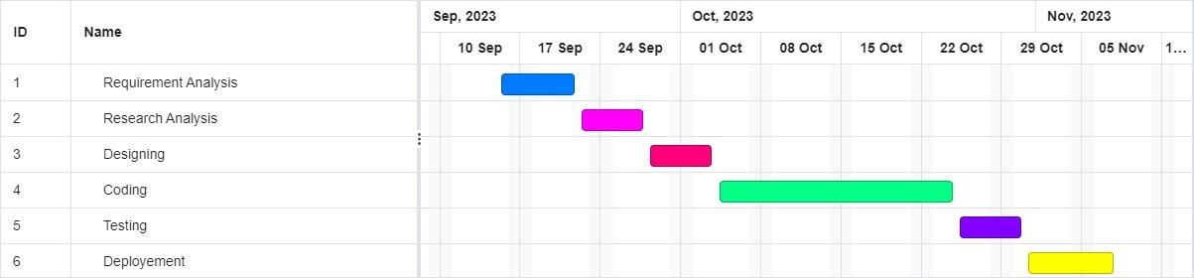

## REFERENCES

Bookchor <https://www.bookchor.com/>

W3 Schools <https://www.w3schools.com/>

Used Books Factory <https://www.usedbooksfactory.com/>